Establishing a Valid Consultation Focus with CLA

- Applying CLA to Government Consultation Projects

Colin Russo, Coordinator Community Consultation, Gold Coast City Council

Community consultation
Community consultation is a two–way communication process - principles and guidelines are followed to ensure collection of input for decision-making purposes. OECD (Organisation for Economic Cooperation and Development) countries such as Australia consult communities to increase the effectiveness of government policies, plans, projects and programs. How do we ensure that community consultation focuses on the issues that are important to the future of communities? One approach is to apply higher standards of consistency and accountability via the CLA model.

Consultation Model

This methods applies Professor Inayatullah’s model of Causal Layered Analysis (CLA) to ensure the preparation and development of valid and democratic community consultation processes.

When we try to answer questions as to what lead the community to a particular view/perspective we may ask: Was it scientific forethought, or the media? Was it a local campaign, or cultural values? Community consultation itself can help the community to form a balanced view, if the consultation process provides a balance of professional input/science and is in the best interests of the community.

The CLA model developed by Inayatullah looks like this:

Four CLA layers
- Litany (lists/labels) – Consultants identify the consultation issues
- Systems (networks) – Consultants understand the affect of issues on networks
- World-view (view issues in larger context) – Consultants contrast issues to wider context
- Mythology (what is believed based on past thinking) – Consultants must identify past thinking

Layer 1 | Layer 2 | Layer 3 | Layer 4
- Quantitative trends  - Problems  - Events  - Issues  - The Unquestioned | - Social causes  - Interpretation  - Occasional analysis  - The role of authorities  - Technical explanations | - Discourse  - Deeper assumptions  - How to revise problem  - Discourse analysis to constitute strategy | - Metaphor  - Myth  - Deep stories  - Unconscious  - The worldview

Where to apply CLA

CLA can provide a focus to:
- An overall program for community consultation e.g. for use in a Corporate Plan or Community Consultation Policy; and
- To specific community consultation projects that deeply scan community issues.

The table below shows examples of four types of community consultation projects in Local Government:

Project areas | Council’s Corporate Plan | Town Plan/  Local Area Plans | Local Laws | Policy | New Strategies  /Strategic Plans | Actions Within a  Strategy | Final or Redesigns of  Strategy Actions | Further Strategy Action consultations prior to implementation | Proactive
Corporate Plan Consultation | ✓
Construction of new pipelines or Roads |  |  |  |  |  | ✓ | ✓ | ✓
Rates charges review |  |  |  |  |  | ✓
Beach Nourishment |  |  |  |  |  | ✓
Vegetation Management Local Law |  |  | ✓
Consultation Policy |  |  |  | ✓
Customer Satisfaction Surveys |  |  |  |  |  |  |  |  | ✓
Town Plan |  | ✓
Communication Strategy |  |  |  |  | ✓
Local Area Plan |  | ✓
 | 1  Plan Consultations |  | 2  Local Laws | 3  Policy | 4 Strategy Consultations

CLA: a Modular Tool

CLA is a vehicle to drive forward valid information and to ask more appropriate questions.

It may mean that the duration of consultation extends to allow additional environmental/stakeholder scanning, identification of the source of community perspectives about a project, and to ensure that the results of the consultation are valid. Internal staff should first be asked their perceptions of their stakeholders.

CLA is not a philosophy, but is a modular tool to analyse layered community content and its causes – the derivation of community’s construction of perspectives/’reality’.

This whole process has some aspects in common with a ‘Social Construction of Reality’, however the addition of Inayatullah’s CLA identifies a range of layered components to focus a consultation project on deeper, more valid understandings of community perspectives.

CLA can be integrated with Individual, Local, State, National perspectives to generate even further levels of analysis. Definitions of these perspectives are in the text The Causal Layered Analysis Reader.
Layers

Litany

System

Worldview

Mythology

Perspectives
IndividualLocalStateWorldview

Benefits of CLA

Tomorrow is the result of our actions and decisions today. CLA is well placed within the futures studies area to contribute to an effective range of techniques that model/diagnose the community perspective to enable better decisions.

- The modular integrations identified in this presentation are of benefit to government consultants because government is interested in the ‘real construction of society’ and not just the social construction of reality. Town plans and regional standards can be improved when government knows how these new developments fit within local and global culture.

- Most techniques do not consider how the community arrived at its decision. CLA offers a guided identification of assumptions made by community and government leading up to the community consultation process.

- The Community Consultation Process is the end point-where information will be gathered. CLA can be used in validation and endorsement of the consultation agenda prior to consultation project implementation. This is a process of diagnosis, deconstruction, reconstruction and decision-making.

SWOT | Analysis
S | Global model being actively researched and applied. Provides a range of perspectives that cover the scientific, political, governmental, spiritual and cultural etc. Reduces controversy and scepticism as it works with either “process” or “content”.
W | Can be targeted as non-specific. Lesser known and needs promotion and development so that it is a well-known field.
O | Develop a consistent enquiry model to gain a valid sample. Reduce costs by applying an holistic model.
T | Project complexity and resource limitations, application to the right projects.

Concluding statements

A decade of research shows an increasing trend toward greater community expectation for community consultation. CLA offers numerous benefits and helps assist in generating accurate and valid community consultation feedback from the community:

- CLA creates a shared language and recognition around changes in community influences and perspectives that lead to swings toward and away from project decisions;

- CLA uses layers to analyse the causes of influences on decision-making. Influences may be based on misinformation. Thus the misinformation may need reconstruction to allow decision makers to focus on valid issues both in community and in government;

- CLA is used to diagnose past community decision-making and to maintain a view of present thinking;

- CLA can be used by community, industry or government organisations as it is cost effective and can be efficiently delivered with other projects.

- Consultation processes should allow a consultant to physically sit with community members and help unravel their story’s to unravel their questions and in fact to help identify their questions.

- CLA is a model or map - that focuses and coordinates the circumstances surrounding the consultation such as how the community arrived at its perspective, who led the community and what this perspective could mean for the future.

- CLA can help to prepare a vision of the preferred future, develop strategy to avoid the least desired future and strategy connected to the preferred future. CLA is a resource for working with the past, the present and the future.

- A well-planned community consultation can help shape a democratic community consultation outcome. Planning prepares consultants for both the implementation and evaluation stages of a consultation project, establishing a consistent scope for consultation issues to be investigated.

The chart below helps to decide to consult or not and where to apply CLA.
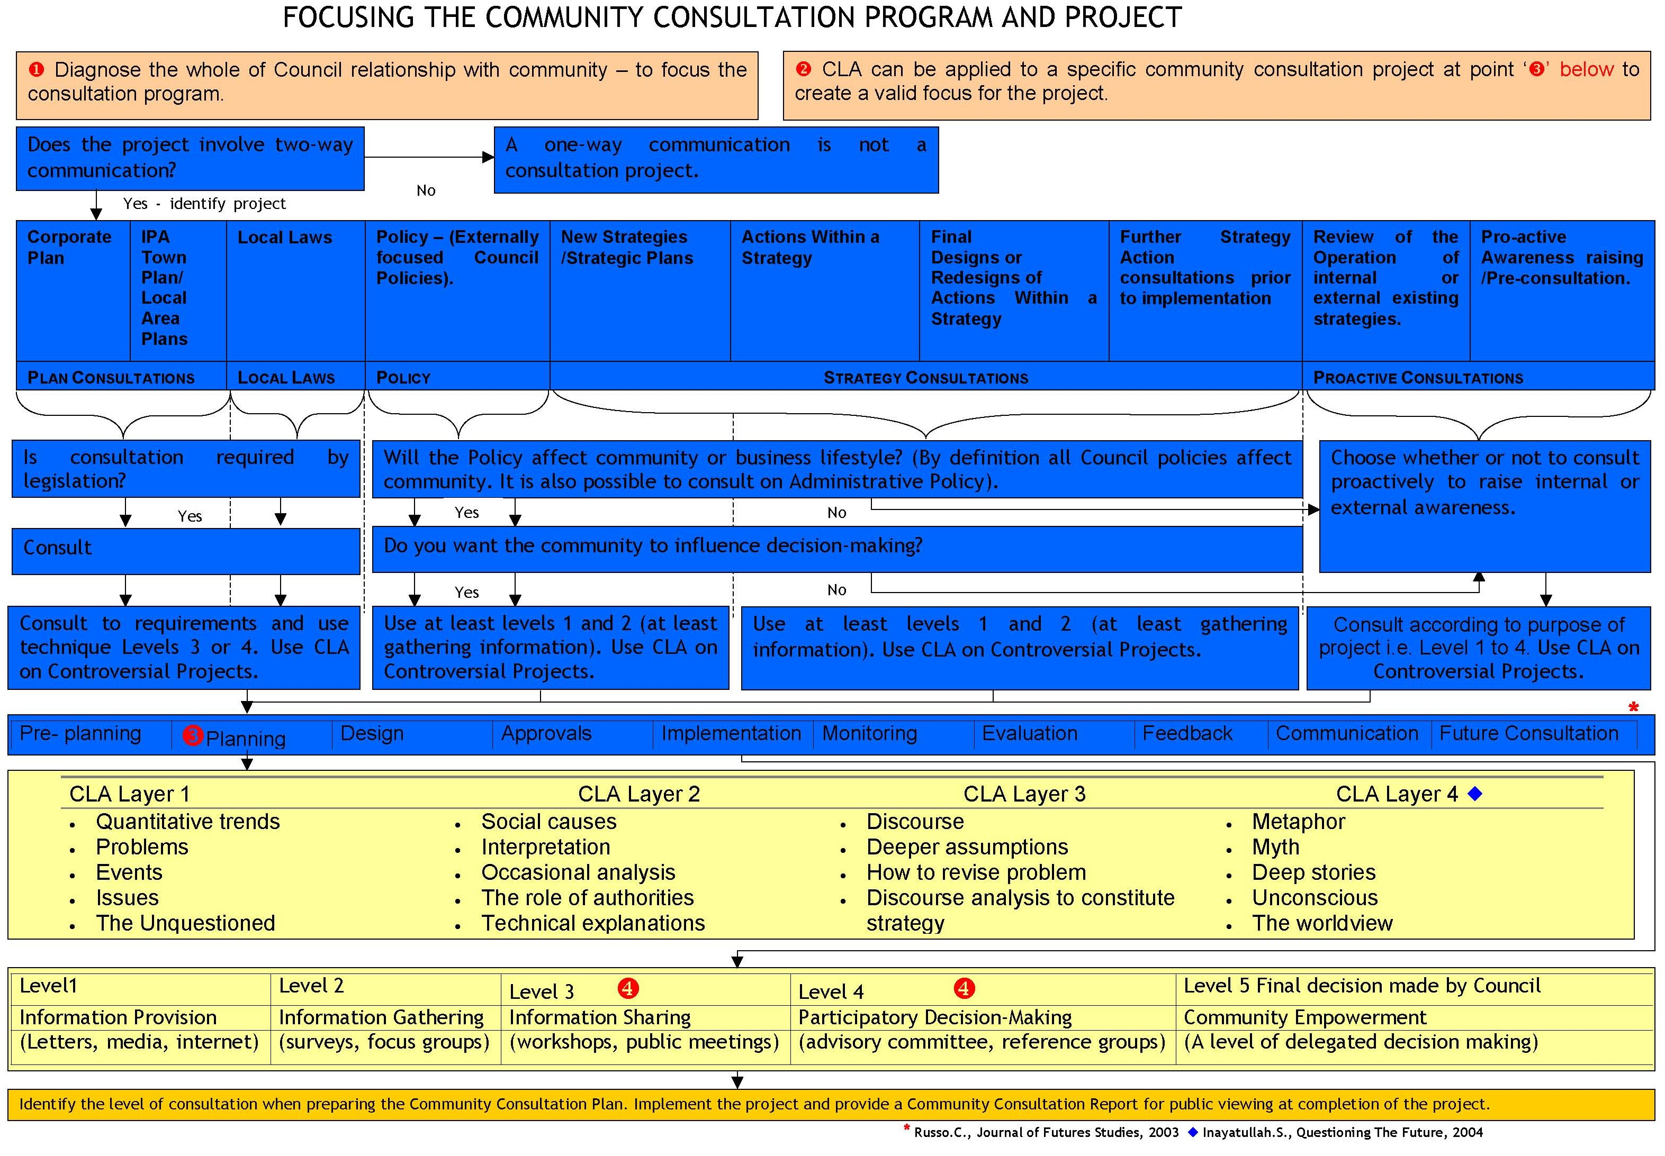

Inayatullah, S. Questioning the Future
ibid
Adapted from Colin Russo, Councillor Magazine: The Quarterly Magazine for Australian Councillors, September/October 2004, pp. 26-28.
Peter L. Berger and Thomas Luckmann. The Social Construction of Reality: A Treatise in the Sociology of Knowledge, Garden City, New York: Anchor Books, 1966, pp. 51-55, 59-61. “All human activity is subject to habitualization. Any action repeated frequently becomes cast into a pattern, which can then be reproduced with an economy of effort and which, ipso facto, is apprehended by its performer as that pattern. Habitualization further implies that the action in question may be performed again in the future in the same manner and with the same economical effort.” Without identifying perspectives and then deconstructing, any miscommunication remains as apparent ‘reality’ – a perspective, that can result in repeated miscommunication and invalid consultation.
Colin Russo, in The Causal Layered Analysis Reader: Theory and Case Studies of a Transformative Methodology, Edited by Sohail Inayatullah, Tamkang University Press, Taiwan, 2004. pp. 506-518.
Market Facts

